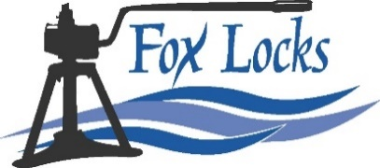
Fox River Navigational System Authority
1008 Augustine St Kaukauna, WI 54130
920-455-9174
www.Foxlocks.org

Agenda
Executive Committee Meeting
Wednesday October 12, 2022, 7:30 AM (CDT)
Location: 1008 Augustine Street, Kaukauna, WI 54130
https://global.gotomeeting.com/join/781018437
United States: +1 (646) 749-3122 Access Code: 781-018-437

Members: Ron Van De Hey (Chair), Jeffery Feldt (Vice Chair), Tim Short (Treasurer), (No Acting Secretary), Philip Ramlet

Attending:

Start: End:

- Review and approval of past meeting minutes
  - Discussion – No September Meeting – review August minutes

- Executive Director Update
  - Discussion
    - Audit Proposals
    - Financial Operation Proposal
    - Electrical Resistivity Update
    - Stellar Blue Proposal
    - Insurance Cancellation Notice – Premises Liability
    - Items for Attorney Rossmeisel
      - Westwood Contract Review
      - Memorial Bench Agreement
    - 2022 Navigation Season Numbers
    - Community Foundation Fundraising Agreement

- Committee Structure
  - Discussion

- Kayak/Canoe Access at Rapide Croche
  - Discussion

- Adjournment:

